**9 SCIENCE 2014**

### PHYSICS TEST TWO

Name: ____________________ Teacher: ___________________ Mark: /43

**Percentage: %**

**SECTION A: MULTIPLE CHOICE (15 marks)**

**Select the most correct answer for each question below.**

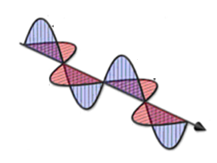

1. Select the name given to the diagram on the right.

(a) Magnetic wave.

(b) Electromagnetic wave.

(c) Electricmagnetic wave.

(d) Electric wave.

2. Choose the correct definition for ‘wave motion’.

(a) The movement of one wave past a point.

(b) The transfer of energy without transferring matter.

(c) The transfer of energy that transfers matter.

(d) The movement of waves in matter.

3. Electromagnetic radiation used in communication are:

(a) Radio waves.

(b) Microwaves.

(c) Infrared radiation.

(d) Both (a) and (b).

4. Choose the correct definition for ‘electromagnetic radiation’.

(a) A range of electromagnetic waves travelling at the speed of light.

(b) A range of magnetic waves travelling at the speed of sound.

(c) Two interconnected fields moving as transverse waves.

(d) A range of electromagnetic waves travelling at the speed of sound.

5. Choose the correct definition for ‘current’.

(a) Movement of electricity.

(b) The flow of charge.

(c) Movement of protons.

(d) The build-up of electric charge.

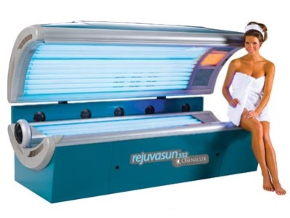6. The machine on the right produces:

(a) Infrared radiation.[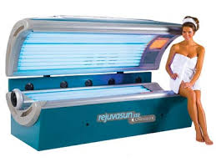](http://www.google.com.au/url?sa=i&rct=j&q=tanning+bed&source=images&cd=&cad=rja&uact=8&docid=D-pA3jdREkVrIM&tbnid=ydVs30u9L9DAZM:&ved=0CAUQjRw&url=http://www.fastnocreditcheckloans.co.uk/Credit_for_tanning_bed_advice.html&ei=0PCrU6q3LYuikwXgtIHICw&psig=AFQjCNE0motNIR6xgLmikY_1JziMKB0qgw&ust=1403863526749397)

(b) Gamma rays.

(c) Ultraviolet light.

(d) X-rays.

7. Choose the correct definition for ‘X-rays’.

(a) Electromagnetic radiation used in communication.

(b) Electromagnetic radiation emitted by radioactive materials.

(c) Electromagnetic radiation detected by our skin as heat.

(d) High energy electromagnetic radiation that can penetrate materials.

8. Choose the correct definition for ‘visible light’.

(a) Electromagnetic radiation detected by our eyes.

(b) Electromagnetic radiation detected by our skin.

(c) Electromagnetic radiation used in communication.

(d) Electromagnetic radiation emitted by radioactive materials.

9. Choose the correct definition for ‘components’.

(a) The parts of a circuit.

(b) The parts of a wave.

(c) The parts of an atom.

(d) The parts of an energy circuit.

10. The nucleus of an atom is made up of:

(a) Protons.

(b) Protons and electrons.

(c) Neutrons and protons.

(d) Electrons and neutrons.

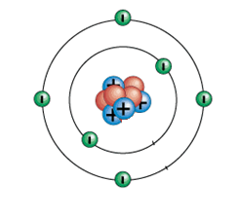11. Choose the correct statement for the atom on the right.

(a) The atom is an ion.

(b) The atom is neutral.

(c) The atom has a negative charge.

(d) Both (a) and (c).

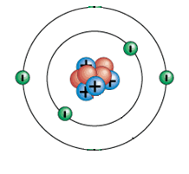12. The atom on the right has a:

(a) Positive charge.

(b) Neutral charge.

(c) Negative charge.

(d) Nucleus charge.

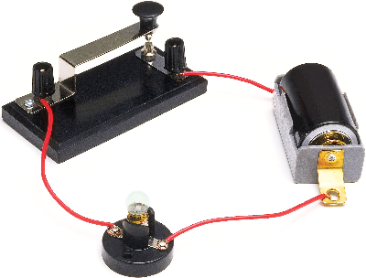

13. The image on the right is an example of:

(a) An electric circuit.

(b) An electric source.

(c) A circuit diagram.

(d) A path of protons.

14. The damaging rays that are emitted in a nuclear explosion are:

(a) Ultraviolet light rays.

(b) Gamma rays.

(c) X-rays.

(d) Infrared radiation.

[](http://www.google.com.au/url?sa=i&rct=j&q=remote+control&source=images&cd=&cad=rja&uact=8&docid=HtMnIH3q5EmhUM&tbnid=yIS_ysv9tIIJMM:&ved=0CAUQjRw&url=http://www.gizmodo.com.au/2012/05/everything-you-need-to-remote-control-your-life/&ei=AeyrU5KVEcnFkQX5mIGoBw&psig=AFQjCNHe7DyZIqoKsFxQ-rv_c-mbUbe-dQ&ust=1403862397742337)

15. The object on the right uses:

(a) Ultraviolet light.

(b) Radio waves.

(c) Infrared radiation.

(d) Gamma rays.

**SECTION B: SHORT ANSWER (28 marks)**

**1.** Label the diagram of the wave below. (1 mark)

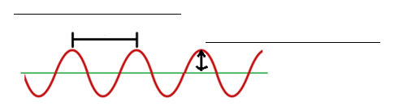

**2.** Write a definition for ‘microwaves’. (2 marks)

_____________________________________________________________________________________

_____________________________________________________________________________________

_____________________________________________________________________________________

**2a.** What is the diagram below called?  (1 mark)

Beryllium

_____________________________________________________________________________________

**b.** Label the diagram below. (3.5 marks)

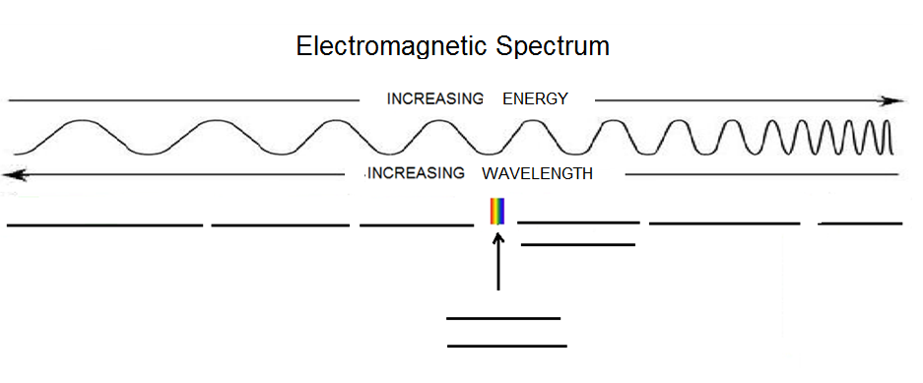

**3.** List three forms of energy released when a spark jumps across a gap. (1 mark)

_____________________________________________________________________________________

**4.** List three things that an electric circuit needs. (3 marks)

_____________________________________________________________________________________

_____________________________________________________________________________________

_____________________________________________________________________________________

**5.** Write a definition for ‘electric circuit’. (2 marks)

_____________________________________________________________________________________

_____________________________________________________________________________________

_____________________________________________________________________________________

**6.** Write a definition for ‘static electricity’. (2 marks)

_____________________________________________________________________________________

_____________________________________________________________________________________

_____________________________________________________________________________________

**7.** Draw a circuit diagram that has an open switch, light globe and battery. (3 marks)

**8.** Fill in the missing words below. (2 marks)

When a plastic rod is rubbed onto a piece of fur, ___________________________ move off the rod and this gives the rod a ________________________ charge.

The fur now has more ______________________ and therefore has a ________________________ charge.

**9.** List two places where electromagnetic waves are generated (created) naturally. (2 marks)

_____________________________________________________________________________________

_____________________________________________________________________________________

**10.** State an example of an energy source that could be used in an electric circuit. (1 mark)

_____________________________________________________________________________________

**11.** Fill in the table below. (4.5 marks)

|  |  |
| --- | --- |
| Component | Diagram |
| Connecting wire |  |
|  |  |
| Switch (open) |  |
|  |  |
|  |  |
| Voltmeter |  |
|  |  |
| Battery |  |
| Resistor |  |